

De La Salle University- Manila
Gokongwei College of Engineering

Project Title : A Sari-Sari Store Web-Based Application for Low-End Devices

Date Submitted : 4/9/2026

Instructor : John Anthony Jose, PhD

Name of Student : Cadiz, Karl Timothy
Student ID : 12309052
Subject / Section : LBYCPG3 / E21

Name of Student : Lofamia, Jared Joshua
Student ID : 12311901
Subject / Section : LBYCPG3 / E21

Name of Student : Rogelio Sebua Jr.
Student ID : 12313300
Subject / Section : LBYCPG3 / E21

Remarks:

____________________________________________________________________________________________________________________________________________________________

Instructor’s Signature : ________________
Page2. Abstract.

This project presents a web-based, lightweight inventory and debt management app that is designed for sari-sari store owners with low-end mobile devices has been developed through this project. These traditional neighborhood stores in the Philippines typically use technology that consists of paper-based records and manual calculation in order to perform their business transactions, thus making it difficult to accurately track and record business processes like sales, expenses, and inventory levels as a consequence of common issues associated with manual data entry, for example, error in calculation, damage to paper records, and loss of paper records.

The aim of this project is to provide a solution to the problem of bridging the gap between manual processes and complex retail software, which are typically complex and depend heavily on cloud-based services by providing a solution with a focus on low data consumption, minimal storage requirements less than 20 MB, and high usability.

The application was developed using a web-based technology stack consisting of HTML, CSS, and JavaScript using the Bootstrap framework for the front-end user interface, PHP and MySQL for back-end data management. Some of the key features include real-time inventory tracking, calculating of debt balances in real-time with the ability to partially pay off a debt balance, and daily sales summary production.

Testing is done on low-end Android devices shows that the app successfully meets all functional requirements and that users are experiencing a seamless user experience with each action completed within 2 seconds. Although the current version of this application requires internet connectivity to access a centralized database, it demonstrates that simplified “mobile first” technology solutions can dramatically enhance both the operational efficiency of micro-retailers and the accuracy of their financial reporting.

Page 3. Table of Contents

- Introduction………………………………………………………………………………6
- Description of the Proposed System…………………………………………………….6
- Objectives…………………………………………………………………………………7
- Web Development Tools and Algorithms….……………………………………………7
- Methodology……………………………………………………………………………...8
- Testing and Evaluation of Results……………………………………………………..10
- References……………………………………………………………………………….13
- Appendices………………………………………………………………………………13

Page 4. List of Figures and Tables

Figure 1: Figma Wireframe ………………………………………………………………………9
Figure 2: Database ……………………………………………………………………….……..10
Table 1: Functional Testing Results….………………………………………………..….……..11
Table 2: Performance Validation Summary….………………………………………..….……..12
Figure 3: Add Inventory..……………………………………………………………..….……..56
Figure 4: Inventory Items……………………………………………………………..….……..57
Figure 5: Edit Item……..……………………………………………………………..….……..58
Figure 6: Delete Item…...……………………………………………………………..….……..59
Figure 7: Record Sales….……………………………………………………………..….……..60
Figure 8: Record Debts….………………………………………………………...…..….……..61
Figure 9: Pay Customer Debt….……………………………………………………..….………62
Figure 10: Summary Page….……………………………...………………………………..…...63

Page 5. List of Abbreviations and Acronyms

- HTML - Hypertext Markup Language
- CSS - Cascading Style Sheets
- PHP - Hypertext Preprocessor
- SQL - Structured Query Language

I. Introduction.
Small neighborhood store owners, commonly sari-sari stores, often rely on handwritten notebooks to manage sales, inventory, and customer debts. While this method is accessible, it frequently leads to calculation errors, misplaced records, and inefficient tracking of daily transactions, ultimately affecting profitability and operational efficiency.

Based on field validation interviews, many store owners struggle to accurately monitor the outstanding balances, manage inventory levels, and summarize sales performance. Despite these challenges, most owners already possess Android smartphones, commonly used for social media and digital wallet applications, such as GCash. This shows an opportunity to transition from manual to digital systems.

However, due to reliance on prepaid mobile data, fully cloud-based solutions may not be practical. Therefore, this project proposes a lightweight web-based sari-sari store inventory and debt management system designed for low data consumption and ease of use. The system prioritizes quick transaction recording, simple navigation, and large, user-friendly interface elements to support efficient day-to-day store operations.

II. Description of the Proposed System.
Sari-sari store owners require a system that can efficiently track customer debts and basic inventory while accommodating constraints such as limited mobile data access, restricted smartphone storage, and the need for ease of use. In response to this, this project proposes a web-based application optimized for low-end mobile devices. The system enables store owners to record debt transactions, manage inventory, monitor customers’ outstanding balances, and generate sales summaries.

The application will be developed using HTML, CSS, JavaScript, and Bootstrap for the frontend, Node.js for the backend, and MySQL for the database. To ensure accessibility and performance, the system will be designed with a total size of under 20 MB and the capability to function with minimal connectivity. The user interface will prioritize readability through large buttons and simple layouts, while the core functionalities will be accessible within no more than three interactions.

To further optimize the storage and battery efficiency, advanced features such as complex analytics, multi-store management, real-time cloud integration, and artificial intelligence will be excluded.

III. Objectives.
General Objective:
To develop a lightweight web-based mobile application for sari-sari store owners that supports efficient tracking of sales, inventory, and customer debts on low-end devices.

Specific Objectives:
- To design and implement a system capable of running on low-end devices with minimal data usage and local storage requirements.
- To provide functionalities for recording and managing sales transactions, customer debts, and basic inventory.
- To enable store owners to monitor outstanding balances and generate simple sales summaries for daily operations.

IV. Web Development Tools and Algorithms.
This section presents the web development tools and core algorithms used in the development of the proposed system, along with their roles and significance.

Web Development Tools:
- HTML (Hypertext Markup Language)
HTML serves as the structural foundation and building blocks of the web application. It defines the content and layout for the interface, including text elements, headings, forms, buttons, lists, tables, and other essential components required for user interaction (Mzizi, 2024).
- CSS (Cascading Style Sheets)
CSS is used to enhance the visual presentation of the application. It defines styles such as colors, fonts, spacing, and layout. Key implementations include the box mode, responsive layouts, and the styling of buttons and item cards to improve readability and usability.
- JavaScript
JavaScript provides the core logic and interactivity of the system. It enables dynamic features such as adding and updating customer records, processing sales and debt transactions, and displaying real-time updates within the user interface.
- Bootstrap
Bootstrap is a front-end framework used to support responsive and mobile-first design. It simplifies the development of the user interface components and ensures compatibility across different screen sizes, essential for low-end mobile devices.
- PHP (Hypertext Preprocessor)
PHP is used as a server-side scripting language to handle communication between the frontend and the database. It processes requests, performs data validation, and executes database operations such as inserting, updating, and retrieving records.
- MySQL
MySQL is used as the database management system for storing and organizing data related to customers, inventory, sales, and debts. It ensures structured data storage and efficient retrieval using queries. The database was managed using phpMyAdmin.

Algorithms Implemented:
- Transaction Recording Algorithm
This algorithm handles the process of recording sales and debt transactions. When a user inputs transaction data, the system validates the input, determines whether the transaction is cash or credit, and stores the corresponding record in the database. This ensures accurate and consistent tracking of store activities.
- Debt Calculation Algorithm
The system computes each customer’s outstanding balance by accumulating unpaid transactions and subtracting recorded payments. This allows store owners to monitor debts in real time and reduce manual calculation errors.
- Inventory Update Algorithm
Whenever a sale is recorded, the system automatically deducts the corresponding quantity from the inventory. This ensures that stock levels remain updated and prevents discrepancies between the actual and recorded inventory.
- Sales Summary Generation Algorithm
This system aggregates transaction data to produce summaries. This involves iterating through stored records and computing totals such as revenue, cash received, and outstanding debts.

V. Methodology.
- Development
A front-end is first developed to visualize how the program will look. A template is created in Figma, and afterward it will be coded in HTML and CSS. The site should contain 4 interfaces using 4 HTML files, namely, “Sell,” "Inventory," “Customers,” and “Summary.” The design is then enhanced using Bootstrap to make it mobile-friendly.

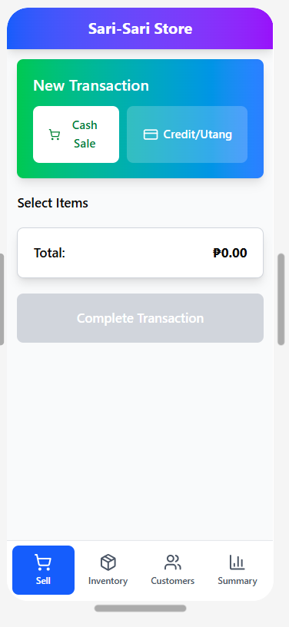
Figure 1. Figma Wireframe
After the front-end development is finished, an SQL database is created to store the website’s data. Five tables were created, containing customers, items, transactions, transaction items, and debt. A PHP script will be used to connect the application to the database.

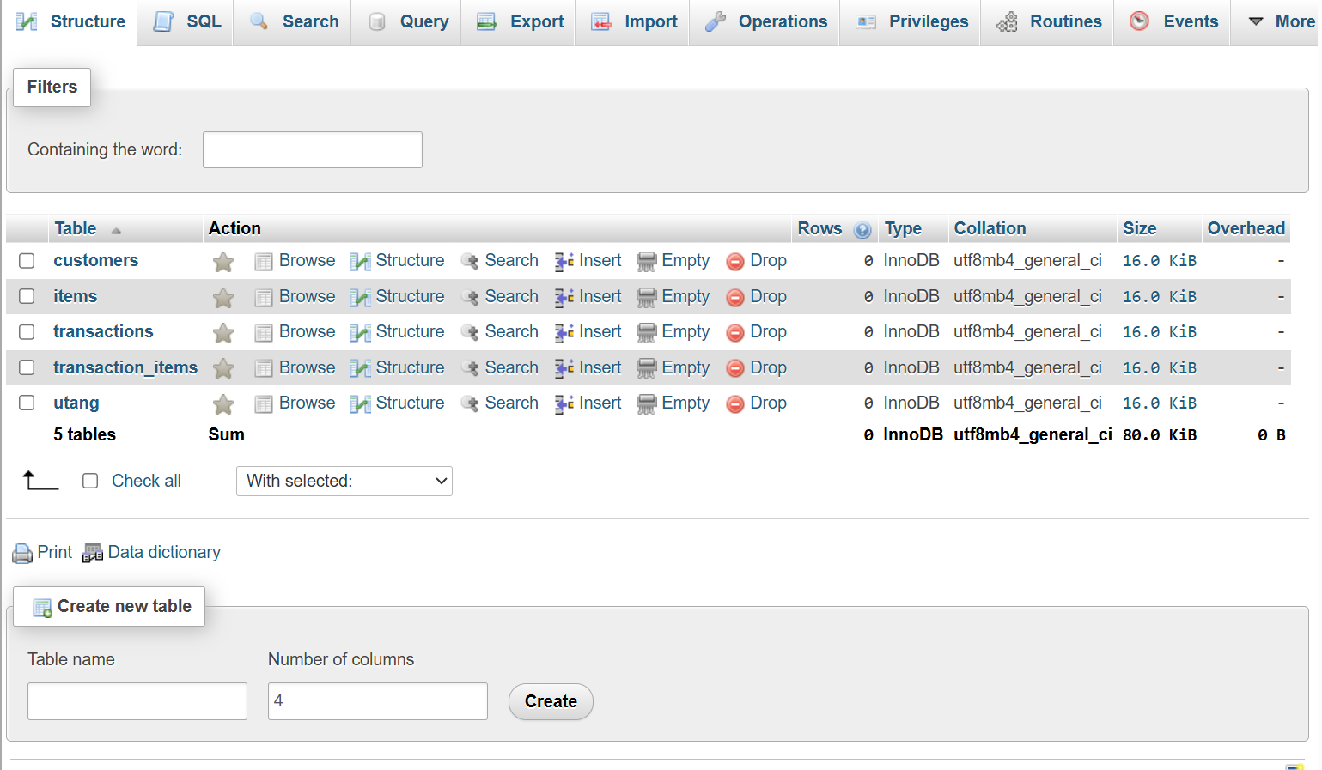
Figure 2. Database

To design the back-end, the JavaScript files will create the logic for adding and deleting the items, customers, and their debts. These files will also provide the application's functionality. The buttons should be enabled for the aforementioned functionalities, and the database should be updated based on the site’s transactions.

- Testing

To thoroughly test the program's functionality, features such as adding inventory, customers, and transactions should work as intended. When adding inventories, for example, a Coke worth 20 Php should be added to the database. For customers, a customer named “Juan” should also be added to the database. During transactions, sales are recorded on the summary page, and inventory items are removed from the database upon completion. Response times should be 1-2 seconds or less, without any crashes, to meet the needs of sari-sari store owners. The testing will be made using an Android device.

VI. Testing and Evaluation of Results
A. Results
Functional Testing
Feature | Expected Result | Actual Result | Status
Record Sale | Sales are recorded | Sales recorded correctly | Passed
Record Debt | Debt is recorded | Balance updated correctly | Passed
View Balances | Correct debt shown | Accurate balance displayed | Passed
Debt Installment | Payment reduces customer debt | Balance reduced correctly | Passed
Update Inventory | Stock is decreased after sales | Inventory updated correctly | Passed
View Sales Summary | Summary shows correct totals and transaction history | Accurate totals and transaction records shown | Passed
Table 1. Functional Testing Results
The table presents the results of functional testing conducted on the system’s core features. All functionalities were verified to operate as intended, ensuring accurate processing of transactions, debt management, and inventory updates.

Performance Validation
The system’s performance was evaluated based on its responsiveness and usability on a low-end Android device. The application operated smoothly when an internet connection was available, with no noticeable delays during core functions. However, the system requires connectivity to function, as it relies on a centralized database for data storage and retrieval. Without an internet connection, the application is unable to load or perform any operations.

Performance Summary
Metric | Observation
App Responsiveness | No noticeable delay during use when connected
Navigation | Smooth and consistent
User Interaction | Tasks completed within a few steps
Connectivity Requirement | Application requires internet connection to function
Offline Availability | System does not operate without internet connection
Database Dependency | All data operations rely on database connectivity
Table 2. Performance Validation Summary

B. Discussion
The results show that the system successfully fulfills its primary objective of providing a simple and efficient tool for sari-sari store owners to manage customers, track debts, and record transactions. Functional testing confirmed that all the core features operate correctly when the system is connected to the internet, including debt management, inventory updates, and sales recording.

The application also met the objective of maintaining ease of use, as tasks can be completed within a few interactions, and the interface remains simple and easy to use. This supports the goal of creating a user-friendly system for non-technical users.

However, the system requires an active internet connection to function, as it relies on a centralized database for data storage and retrieval. This limitation may affect usability in areas with unstable or limited connectivity. Despite this, the system remains suitable for users with basic internet access, which aligns with the initial assumption that store owners already use smartphones and have access to mobile data.

Overall, the outcomes are consistent with the proposed objectives in terms of simplicity, usability, and core functionality, while acknowledging the dependency on internet connectivity.

C. Conclusion
The project successfully developed a web-based application that supports sari-sari store owners in managing sales, inventory, and customer debts. The system provides a simple and structured approach to recording transactions and monitoring outstanding balances to reduce reliance on manual record-keeping methods.

The key contribution of the system lies in its ease of use and ability to optimize basic store operations through a lightweight interface. Testing results confirm that the application performs its intended functions effectively when an internet connection is available.

For future improvements, the system may be enhanced by incorporating offline functionality, enabling data synchronization once connectivity is restored, and expanding reporting features for better analysis of store performance. These improvements could further increase the system’s usability and accessibility for a wider range of users.

VII. References
Mzizi, S. (2024). HTML, CSS, and JavaScript: Essential front-end languages explained. ITonlinelearning. https://www.itonlinelearning.com/blog/html-css-and-javascript-essential-front-end-languages-explained/#:~:text=Programming%20languages%20are%20the%20building,functionality%20to%20the%20web%20page.

VIII. Appendices:
A. Source code used in the web development

customers.html
<!DOCTYPE html>
<html lang="en">
<head>
<meta charset="UTF-8">
<meta name="viewport" content="width=device-width, initial-scale=1.0, maximum-scale=1.0, user-scalable=no">
<title>Sari-Sari Store — Customers</title>
<link href="https://fonts.googleapis.com/css2?family=Nunito:wght@400;600;700;800;900&display=swap" rel="stylesheet">
<style>
* { box-sizing: border-box; margin: 0; padding: 0; -webkit-tap-highlight-color: transparent; }
:root {
--primary-blue: #6146ff;
--active-blue: #226cff;
--rainbow: linear-gradient(135deg, #00c6ff 0%, #0072ff 100%);
--gray-bg: #f8f9fa;
--text-dark: #1a1d23;
--text-muted: #adb5bd;
--border: #e9ecef;
--bottom-nav-h: 75px;
--red: #e53935;
--green: #43a047;
--orange: #ef6c00;
}
body {
font-family: 'Nunito', sans-serif;
background: var(--gray-bg);
color: var(--text-dark);
min-height: 100dvh;
padding-bottom: calc(var(--bottom-nav-h) + 20px);
}
.topbar {
background: var(--primary-blue); padding: 18px;
position: sticky; top: 0; z-index: 100;
text-align: center; color: white;
box-shadow: 0 2px 8px rgba(0,0,0,0.1);
}
.topbar h1 { font-size: 1.2rem; font-weight: 800; }
.page { padding: 16px; max-width: 500px; margin: auto; }

/* Summary Bar */
.summary-bar {
background: var(--rainbow);
border-radius: 20px; padding: 20px;
margin-bottom: 20px; color: white;
}
.summary-bar .lbl { font-size: 0.9rem; font-weight: 700; opacity: 0.85; }
.summary-bar .amt { font-size: 1.8rem; font-weight: 900; margin-top: 4px; }

.section-label { font-size: 0.95rem; font-weight: 800; color: #000; margin-bottom: 12px; }

/* Customer Cards */
.customer-list { display: flex; flex-direction: column; gap: 10px; margin-bottom: 20px; }
.customer-card {
background: white; border: 1px solid var(--border);
border-radius: 15px; padding: 15px;
}
.customer-top {
display: flex; align-items: center;
justify-content: space-between; margin-bottom: 10px;
}
.customer-name { font-weight: 800; font-size: 1rem; }
.customer-total { font-size: 1rem; font-weight: 900; color: var(--orange); }
.customer-total.paid { color: var(--green); }

/* Utang items */
.utang-list { display: flex; flex-direction: column; gap: 8px; }
.utang-item {
background: var(--gray-bg); border-radius: 12px; padding: 12px;
}
.utang-item-header {
display: flex; justify-content: space-between; align-items: flex-start;
margin-bottom: 8px;
}
.utang-item-date { font-size: 0.78rem; color: var(--text-muted); font-weight: 600; }
.utang-item-total { font-size: 0.85rem; font-weight: 700; color: var(--text-dark); }

/* Progress bar */
.progress-wrap { margin-bottom: 8px; }
.progress-labels {
display: flex; justify-content: space-between;
font-size: 0.78rem; font-weight: 700; margin-bottom: 4px;
}
.progress-paid { color: var(--green); }
.progress-remaining { color: var(--orange); }
.progress-bar-bg {
background: #e0e0e0; border-radius: 10px; height: 8px; overflow: hidden;
}
.progress-bar-fill {
height: 100%; border-radius: 10px;
background: var(--green); transition: width 0.3s;
}

/* Payment row */
.pay-row { display: flex; gap: 8px; align-items: center; }
.pay-input {
flex: 1; padding: 10px 12px; border-radius: 10px;
border: 1.5px solid var(--border); background: white;
font-family: inherit; font-size: 0.9rem; font-weight: 700;
color: var(--text-dark); outline: none;
}
.pay-input:focus { border-color: var(--active-blue); }
.pay-btn {
padding: 10px 16px; border-radius: 10px; border: none;
background: var(--active-blue); color: white;
font-family: inherit; font-size: 0.85rem; font-weight: 800;
cursor: pointer; white-space: nowrap;
}
.pay-btn:active { opacity: 0.7; }
.pay-full-btn {
padding: 10px 16px; border-radius: 10px; border: none;
background: #e8f5e9; color: var(--green);
font-family: inherit; font-size: 0.85rem; font-weight: 800;
cursor: pointer; white-space: nowrap;
}
.pay-full-btn:active { opacity: 0.7; }

.utang-status {
font-size: 0.78rem; font-weight: 800;
padding: 3px 10px; border-radius: 20px;
}
.utang-status.paid { background: #e8f5e9; color: var(--green); }

/* Bottom Nav */
.bottom-nav {
position: fixed; bottom: 0; left: 0; right: 0; height: var(--bottom-nav-h);
background: white; border-top: 1px solid var(--border);
display: flex; justify-content: space-around; align-items: center; z-index: 200;
}
.nav-item { flex: 1; text-decoration: none; display: flex; justify-content: center; color: #5f6368; }
.nav-icon-wrap {
display: flex; flex-direction: column; align-items: center;
justify-content: center; width: 85px; height: 60px; border-radius: 14px; gap: 2px;
}
.nav-item.active { color: white; }
.nav-item.active .nav-icon-wrap { background: var(--active-blue); }
.nav-item span:first-child { font-size: 1.3rem; }
.nav-item span:last-child { font-size: 0.75rem; font-weight: 700; }

.toast {
position: fixed; bottom: 100px; left: 50%; transform: translateX(-50%);
background: #323232; color: white; padding: 12px 24px; border-radius: 50px;
font-size: 0.9rem; opacity: 0; transition: 0.3s; z-index: 1000;
}
.toast.show { opacity: 1; }
</style>
</head>
<body>

<div class="topbar"><h1>Customers</h1></div>

<div class="page">
<div class="summary-bar">
<div class="lbl">Total Unpaid Utang</div>
<div class="amt">₱<span id="totalUnpaid">0.00</span></div>
</div>

<div class="section-label">Customer Debts</div>
<div class="customer-list" id="customerList"></div>
</div>

<nav class="bottom-nav">
<a href="sell.html" class="nav-item">
<div class="nav-icon-wrap"><span>🛒</span><span>Sell</span></div>
</a>
<a href="inventory.html" class="nav-item">
<div class="nav-icon-wrap"><span>📦</span><span>Inventory</span></div>
</a>
<a href="customers.html" class="nav-item active">
<div class="nav-icon-wrap"><span>👥</span><span>Customers</span></div>
</a>
<a href="summary.html" class="nav-item">
<div class="nav-icon-wrap"><span>📊</span><span>Summary</span></div>
</a>
</nav>

<div class="toast" id="toast"></div>

<script>
const API = {
customers: 'api/get_customers.php',
pay: 'api/pay_utang.php'
};

async function loadCustomers() {
const el = document.getElementById('customerList');
el.innerHTML = '<p style="text-align:center;color:gray;padding:20px 0">Loading…</p>';
try {
const res = await fetch(API.customers);
const data = JSON.parse(await res.text());
if (!data.success) throw new Error(data.error);
renderCustomers(data.customers);
updateTotalUnpaid(data.customers);
} catch (err) {
el.innerHTML = `<p style="text-align:center;color:red;padding:20px 0;font-size:0.85rem">❌ ${err.message}</p>`;
}
}

function updateTotalUnpaid(customers) {
let total = 0;
customers.forEach(c => {
c.utangs.forEach(u => {
if (u.status === 'unpaid') {
total += parseFloat(u.amount) - parseFloat(u.paid_amount || 0);
}
});
});
document.getElementById('totalUnpaid').innerText = total.toFixed(2);
}

function renderCustomers(customers) {
const el = document.getElementById('customerList');
if (customers.length === 0) {
el.innerHTML = '<p style="text-align:center;color:gray;padding:20px 0">No customers yet.</p>';
return;
}

el.innerHTML = customers.map(c => {
const unpaidTotal = c.utangs
.filter(u => u.status === 'unpaid')
.reduce((sum, u) => sum + (parseFloat(u.amount) - parseFloat(u.paid_amount || 0)), 0);
const allPaid = unpaidTotal === 0;

const utangRows = c.utangs.map(u => {
const total = parseFloat(u.amount);
const paid = parseFloat(u.paid_amount || 0);
const remaining = total - paid;
const pct = Math.min(100, (paid / total) * 100).toFixed(1);
const isPaid = u.status === 'paid';

return `
<div class="utang-item">
<div class="utang-item-header">
<div>
<div class="utang-item-date">${formatDate(u.created_at)}</div>
<div class="utang-item-total">Total: ₱${total.toFixed(2)}</div>
</div>
${isPaid
? '<span class="utang-status paid">✅ Fully Paid</span>'
: `<span style="font-size:0.85rem;font-weight:900;color:var(--orange)">₱${remaining.toFixed(2)} left</span>`
}
</div>

<div class="progress-wrap">
<div class="progress-labels">
<span class="progress-paid">Paid ₱${paid.toFixed(2)}</span>
${!isPaid ? `<span class="progress-remaining">${pct}%</span>` : ''}
</div>
<div class="progress-bar-bg">
<div class="progress-bar-fill" style="width:${pct}%"></div>
</div>
</div>

${!isPaid ? `
<div class="pay-row">
<input
type="number"
class="pay-input"
id="pay-amt-${u.id}"
placeholder="Enter amount"
min="1"
max="${remaining.toFixed(2)}"
step="0.01"
>
<button class="pay-btn" onclick="payPartial(${u.id}, ${remaining.toFixed(2)})">Pay</button>
<button class="pay-full-btn" onclick="payFull(${u.id}, ${remaining.toFixed(2)})">Full</button>
</div>` : ''}
</div>`;
}).join('');

return `
<div class="customer-card">
<div class="customer-top">
<div class="customer-name">👤 ${c.name}</div>
<div class="customer-total ${allPaid ? 'paid' : ''}">
${allPaid ? '✅ All paid' : '₱' + unpaidTotal.toFixed(2)}
</div>
</div>
<div class="utang-list">${utangRows}</div>
</div>`;
}).join('');
}

// Pay a custom amount
async function payPartial(id, remaining) {
const input = document.getElementById(`pay-amt-${id}`);
const amount = parseFloat(input.value);

if (isNaN(amount) || amount <= 0) {
showToast('⚠️ Enter a valid amount'); return;
}
if (amount > remaining) {
showToast(`⚠️ Max payment is ₱${remaining.toFixed(2)}`); return;
}
await submitPayment(id, amount);
}

// Pay the full remaining balance
async function payFull(id, remaining) {
if (!confirm(`Pay full remaining ₱${remaining.toFixed(2)}?`)) return;
await submitPayment(id, remaining);
}

async function submitPayment(id, amount) {
try {
const res = await fetch(API.pay, {
method: 'POST',
headers: { 'Content-Type': 'application/json' },
body: JSON.stringify({ id, amount })
});
const data = JSON.parse(await res.text());
if (!data.success) throw new Error(data.error);
showToast(data.status === 'paid' ? '✅ Fully paid!' : '✅ Payment recorded!');
loadCustomers();
} catch (err) { showToast('❌ ' + err.message); }
}

function formatDate(dateStr) {
if (!dateStr) return '';
const d = new Date(dateStr);
return d.toLocaleDateString('en-PH', { month: 'short', day: 'numeric', year: 'numeric' });
}

function showToast(msg) {
const t = document.getElementById('toast');
t.textContent = msg;
t.classList.add('show');
setTimeout(() => t.classList.remove('show'), 2500);
}

loadCustomers();
</script>
</body>
</html>


inventory.html

<!DOCTYPE html>
<html lang="en">
<head>
<meta charset="UTF-8">
<meta name="viewport" content="width=device-width, initial-scale=1.0, maximum-scale=1.0, user-scalable=no">
<title>Sari-Sari Store — Inventory</title>
<link href="https://fonts.googleapis.com/css2?family=Nunito:wght@400;600;700;800;900&display=swap" rel="stylesheet">
<link rel="stylesheet" href="css/style.css">
<style>
.add-form { display: flex; flex-direction: column; gap: 10px; }
.add-form input {
width: 100%; padding: 12px; border-radius: 12px; border: none;
background: white; font-family: inherit; font-weight: 600;
font-size: 0.95rem; outline: none; color: var(--text-dark);
}
.add-row { display: flex; gap: 10px; }
.add-row input { flex: 1; }
.add-btn {
width: 100%; padding: 13px; border: none; border-radius: 12px;
background: white; color: var(--primary-blue);
font-family: inherit; font-size: 0.95rem; font-weight: 800;
cursor: pointer; transition: opacity 0.2s;
}
.item-actions { display: flex; gap: 8px; }
.edit-btn, .del-btn {
padding: 8px 14px; border-radius: 10px; border: none;
font-family: inherit; font-size: 0.82rem; font-weight: 800; cursor: pointer;
}
.edit-btn { background: #e8f0fe; color: var(--active-blue); }
.del-btn { background: #fdecea; color: var(--red); }

/* Modal Styles */
.modal-overlay {
display: none; position: fixed; inset: 0;
background: rgba(0,0,0,0.45); z-index: 500;
align-items: center; justify-content: center; padding: 20px;
}
.modal-overlay.show { display: flex; }
.modal {
background: white; border-radius: 20px; padding: 24px;
width: 100%; max-width: 400px;
}
.modal-btns { display: flex; gap: 10px; margin-top: 10px; }
.modal-save { flex: 1; padding: 13px; border: none; border-radius: 12px; background: var(--active-blue); color: white; font-weight: 800; cursor: pointer; }
.modal-cancel { flex: 1; padding: 13px; border: 1.5px solid var(--border); border-radius: 12px; background: white; font-weight: 800; cursor: pointer; }
</style>
</head>
<body>

<div class="topbar"><h1>Inventory</h1></div>

<div class="page">
<div class="rainbow-card">
<div class="card-label">Add New Item</div>
<div class="add-form">
<input type="text" id="newName" placeholder="Item name">
<div class="add-row">
<input type="number" id="newPrice" placeholder="Price (₱)" min="0" step="0.01">
<input type="number" id="newStock" placeholder="Stock qty" min="0" step="1">
</div>
<button class="add-btn" onclick="addItem()">+ Add Item</button>
</div>
</div>

<div class="section-label">All Items</div>
<div id="itemList"></div>
</div>

<div class="modal-overlay" id="editModal">
<div class="modal">
<h2 style="margin-bottom:15px">Edit Item</h2>
<input type="hidden" id="editId">
<input type="text" id="editName" placeholder="Item name" style="width:100%; padding:12px; margin-bottom:10px; border-radius:10px; border:1px solid #ddd">
<div class="add-row" style="margin-bottom:10px">
<input type="number" id="editPrice" placeholder="Price" style="width:100%; padding:12px; border-radius:10px; border:1px solid #ddd">
<input type="number" id="editStock" placeholder="Stock" style="width:100%; padding:12px; border-radius:10px; border:1px solid #ddd">
</div>
<div class="modal-btns">
<button class="modal-cancel" onclick="closeModal()">Cancel</button>
<button class="modal-save" onclick="saveEdit()">Save</button>
</div>
</div>
</div>

<nav class="bottom-nav">
<a href="sell.html" class="nav-item">
<div class="nav-icon-wrap"><span>🛒</span><span>Sell</span></div>
</a>
<a href="inventory.html" class="nav-item active">
<div class="nav-icon-wrap"><span>📦</span><span>Inventory</span></div>
</a>
<a href="customers.html" class="nav-item">
<div class="nav-icon-wrap"><span>👥</span><span>Customers</span></div>
</a>
<a href="summary.html" class="nav-item">
<div class="nav-icon-wrap"><span>📊</span><span>Summary</span></div>
</a>
</nav>

<div class="toast" id="toast"></div>

<script src="js/inventory.js"></script>
</body>
</html>


Sell.html

<!DOCTYPE html>
<html lang="en">
<head>
<meta charset="UTF-8">
<meta name="viewport" content="width=device-width, initial-scale=1.0, maximum-scale=1.0, user-scalable=no">
<title>Sari-Sari Store — Sell</title>
<link href="https://fonts.googleapis.com/css2?family=Nunito:wght@400;700;900&display=swap" rel="stylesheet">
<link rel="stylesheet" href="css/style.css">
<style>
/* Page-specific toggles */
.mode-toggle { display: flex; background: rgba(255,255,255,0.2); border-radius: 14px; padding: 4px; gap: 4px; }
.mode-toggle label { flex: 1; text-align: center; padding: 12px; border-radius: 10px; font-size: 0.9rem; font-weight: 700; color: white; cursor: pointer; }
.mode-toggle input { display: none; }
.mode-toggle input:checked + label { background: white; color: #009688; }
.customer-field { margin-top: 12px; display: none; }
.customer-field.visible { display: block; }
.customer-field input { width: 100%; padding: 12px; border-radius: 12px; border: none; outline: none; font-weight: 600; }
.complete-btn { width: 100%; padding: 18px; border: none; border-radius: 15px; font-size: 1rem; font-weight: 800; color: white; background: #ced4da; cursor: not-allowed; }
.complete-btn.active-ready { background: var(--active-blue); cursor: pointer; }
</style>
</head>
<body>
<div class="topbar"><h1>Sari-Sari Store</h1></div>
<div class="page">
<div class="rainbow-card">
<div class="card-label">New Transaction</div>
<div class="mode-toggle">
<input type="radio" name="saleType" id="cash" checked>
<label for="cash" onclick="updateMode('cash')">🛒 Cash Sale</label>
<input type="radio" name="saleType" id="utang">
<label for="utang" onclick="updateMode('utang')">💳 Credit/Utang</label>
</div>
<div class="customer-field" id="customerDiv">
<input type="text" id="customerName" placeholder="👤 Who is borrowing?" oninput="refreshUI()">
</div>
</div>
<div class="section-label">Select Items</div>
<div id="itemList"></div>
<div class="tx-card" style="display:flex; justify-content: space-between; align-items: center;">
<span style="font-weight:700">Total:</span>
<span style="font-size:1.2rem; font-weight:900">₱<span id="totalDisplay">0.00</span></span>
</div>
<button class="complete-btn" id="completeBtn" onclick="processSale()" disabled>Complete Transaction</button>
</div>

<nav class="bottom-nav">
<a href="sell.html" class="nav-item active"><div class="nav-icon-wrap"><span>🛒</span><span>Sell</span></div></a>
<a href="inventory.html" class="nav-item"><div class="nav-icon-wrap"><span>📦</span><span>Inventory</span></div></a>
<a href="customers.html" class="nav-item"><div class="nav-icon-wrap"><span>👥</span><span>Customers</span></div></a>
<a href="summary.html" class="nav-item"><div class="nav-icon-wrap"><span>📊</span><span>Summary</span></div></a>
</nav>
<div class="toast" id="toast"></div>
<script src="js/sell.js"></script>
</body>
</html>


Summary.html

<!DOCTYPE html>
<html lang="en">
<head>
<meta charset="UTF-8">
<meta name="viewport" content="width=device-width, initial-scale=1.0, maximum-scale=1.0, user-scalable=no">
<title>Sari-Sari Store — Summary</title>
<link href="https://fonts.googleapis.com/css2?family=Nunito:wght@400;600;700;800;900&display=swap" rel="stylesheet">
<link rel="stylesheet" href="css/style.css">
<style>
/* Page-specific styles for the Summary Dashboard */
.today-total { font-size: 2rem; font-weight: 900; margin-bottom: 4px; }
.today-sub { font-size: 0.85rem; font-weight: 700; opacity: 0.85; }

.stat-row { display: flex; gap: 10px; margin-bottom: 16px; }
.stat-card {
flex: 1; background: white; border: 1px solid var(--border);
border-radius: 15px; padding: 14px; text-align: center;
}
.stat-label { font-size: 0.8rem; font-weight: 700; color: var(--text-muted); margin-bottom: 6px; }
.stat-value { font-size: 1.15rem; font-weight: 900; }
.stat-value.cash { color: var(--green); }
.stat-value.utang { color: var(--orange); }

.filter-tabs { display: flex; gap: 8px; margin-bottom: 14px; }
.filter-tab {
padding: 8px 16px; border-radius: 20px; border: 1.5px solid var(--border);
background: white; font-family: inherit; font-size: 0.85rem;
font-weight: 700; color: var(--text-muted); cursor: pointer;
}
.filter-tab.active {
background: var(--active-blue); border-color: var(--active-blue); color: white;
}

.tx-type {
display: inline-block; font-size: 0.78rem; font-weight: 800;
padding: 3px 10px; border-radius: 20px; margin-bottom: 4px;
}
.tx-type.cash { background: #e8f5e9; color: var(--green); }
.tx-type.utang { background: #fff3e0; color: var(--orange); }
</style>
</head>
<body>

<div class="topbar"><h1>Summary</h1></div>

<div class="page">
<div class="rainbow-card">
<div class="card-label">Today's Sales</div>
<div class="today-total">₱<span id="todayTotal">0.00</span></div>
<div class="today-sub"><span id="todayCount">0</span> transactions today</div>
</div>

<div class="stat-row">
<div class="stat-card">
<div class="stat-label">💵 Cash Today</div>
<div class="stat-value cash">₱<span id="cashTotal">0.00</span></div>
</div>
<div class="stat-card">
<div class="stat-label">💳 Utang Today</div>
<div class="stat-value utang">₱<span id="utangTotal">0.00</span></div>
</div>
</div>

<div class="section-label">Transactions</div>
<div class="filter-tabs">
<button class="filter-tab active" onclick="setFilter('all', this)">All</button>
<button class="filter-tab" onclick="setFilter('cash', this)">Cash</button>
<button class="filter-tab" onclick="setFilter('utang', this)">Utang</button>
</div>

<div id="txList">
</div>
</div>

<nav class="bottom-nav">
<a href="sell.html" class="nav-item">
<div class="nav-icon-wrap"><span>🛒</span><span>Sell</span></div>
</a>
<a href="inventory.html" class="nav-item">
<div class="nav-icon-wrap"><span>📦</span><span>Inventory</span></div>
</a>
<a href="customers.html" class="nav-item">
<div class="nav-icon-wrap"><span>👥</span><span>Customers</span></div>
</a>
<a href="summary.html" class="nav-item active">
<div class="nav-icon-wrap"><span>📊</span><span>Summary</span></div>
</a>
</nav>

<div class="toast" id="toast"></div>

<script src="js/summary.js"></script>
</body>
</html>


Sari_sari_db.sql

-- phpMyAdmin SQL Dump
-- version 5.2.1
-- https://www.phpmyadmin.net/
--
-- Host: 127.0.0.1
-- Generation Time: Apr 09, 2026 at 11:19 AM
-- Server version: 10.4.32-MariaDB
-- PHP Version: 8.2.12

SET SQL_MODE = "NO_AUTO_VALUE_ON_ZERO";
START TRANSACTION;
SET time_zone = "+00:00";

/*!40101 SET @OLD_CHARACTER_SET_CLIENT=@@CHARACTER_SET_CLIENT */;
/*!40101 SET @OLD_CHARACTER_SET_RESULTS=@@CHARACTER_SET_RESULTS */;
/*!40101 SET @OLD_COLLATION_CONNECTION=@@COLLATION_CONNECTION */;
/*!40101 SET NAMES utf8mb4 */;

--
-- Database: `sari_sari_db`
--

-- --------------------------------------------------------

--
-- Table structure for table `customers`
--

CREATE TABLE `customers` (
`id` int(11) UNSIGNED NOT NULL,
`name` varchar(50) NOT NULL,
`created_at` datetime NOT NULL
) ENGINE=InnoDB DEFAULT CHARSET=utf8mb4 COLLATE=utf8mb4_general_ci;

--
-- Dumping data for table `customers`
--

INSERT INTO `customers` (`id`, `name`, `created_at`) VALUES
(1, 'Jared', '2026-04-09 16:11:50'),
(2, 'Karl', '2026-04-09 16:41:13');

-- --------------------------------------------------------

--
-- Table structure for table `items`
--

CREATE TABLE `items` (
`id` int(11) UNSIGNED NOT NULL,
`name` varchar(50) NOT NULL,
`price` double NOT NULL,
`stock` int(11) NOT NULL,
`created_at` datetime NOT NULL
) ENGINE=InnoDB DEFAULT CHARSET=utf8mb4 COLLATE=utf8mb4_general_ci;

--
-- Dumping data for table `items`
--

INSERT INTO `items` (`id`, `name`, `price`, `stock`, `created_at`) VALUES
(2, 'Coke', 20, 1, '2026-04-09 16:06:21'),
(3, 'Pen', 30, 1, '2026-04-09 16:31:39');

-- --------------------------------------------------------

--
-- Table structure for table `transactions`
--

CREATE TABLE `transactions` (
`id` int(11) UNSIGNED NOT NULL,
`type` varchar(50) NOT NULL,
`total_amount` double NOT NULL,
`created_at` datetime NOT NULL
) ENGINE=InnoDB DEFAULT CHARSET=utf8mb4 COLLATE=utf8mb4_general_ci;

--
-- Dumping data for table `transactions`
--

INSERT INTO `transactions` (`id`, `type`, `total_amount`, `created_at`) VALUES
(1, 'cash', 60, '2026-04-09 16:08:52'),
(2, 'utang', 40, '2026-04-09 16:11:50'),
(3, 'utang', 20, '2026-04-09 16:12:56'),
(4, 'utang', 20, '2026-04-09 16:26:10'),
(5, 'utang', 30, '2026-04-09 16:31:45'),
(6, 'utang', 50, '2026-04-09 16:32:35'),
(7, 'utang', 60, '2026-04-09 16:41:13');

-- --------------------------------------------------------

--
-- Table structure for table `transaction_items`
--

CREATE TABLE `transaction_items` (
`id` int(11) UNSIGNED NOT NULL,
`transaction_id` int(11) NOT NULL,
`item_id` int(11) NOT NULL,
`quantity` int(11) NOT NULL,
`price` float NOT NULL
) ENGINE=InnoDB DEFAULT CHARSET=utf8mb4 COLLATE=utf8mb4_general_ci;

--
-- Dumping data for table `transaction_items`
--

INSERT INTO `transaction_items` (`id`, `transaction_id`, `item_id`, `quantity`, `price`) VALUES
(1, 1, 2, 3, 20),
(2, 2, 2, 2, 20),
(3, 3, 2, 1, 20),
(4, 4, 2, 1, 20),
(5, 5, 3, 1, 30),
(6, 6, 2, 1, 20),
(7, 6, 3, 1, 30),
(8, 7, 3, 2, 30);

-- --------------------------------------------------------

--
-- Table structure for table `utang`
--

CREATE TABLE `utang` (
`id` int(11) UNSIGNED NOT NULL,
`customer_id` int(11) NOT NULL,
`transaction_id` int(11) NOT NULL,
`amount` double NOT NULL,
`paid_amount` double DEFAULT 0,
`status` varchar(50) NOT NULL
) ENGINE=InnoDB DEFAULT CHARSET=utf8mb4 COLLATE=utf8mb4_general_ci;

--
-- Dumping data for table `utang`
--

INSERT INTO `utang` (`id`, `customer_id`, `transaction_id`, `amount`, `paid_amount`, `status`) VALUES
(1, 1, 2, 40, 0, 'paid'),
(2, 1, 3, 20, 0, 'paid'),
(3, 1, 4, 20, 20, 'paid'),
(4, 1, 5, 30, 30, 'paid'),
(5, 1, 6, 50, 50, 'paid'),
(6, 2, 7, 60, 60, 'paid');

--
-- Indexes for dumped tables
--

--
-- Indexes for table `customers`
--
ALTER TABLE `customers`
ADD PRIMARY KEY (`id`);

--
-- Indexes for table `items`
--
ALTER TABLE `items`
ADD PRIMARY KEY (`id`);

--
-- Indexes for table `transactions`
--
ALTER TABLE `transactions`
ADD PRIMARY KEY (`id`);

--
-- Indexes for table `transaction_items`
--
ALTER TABLE `transaction_items`
ADD PRIMARY KEY (`id`);

--
-- Indexes for table `utang`
--
ALTER TABLE `utang`
ADD PRIMARY KEY (`id`);

--
-- AUTO_INCREMENT for dumped tables
--

--
-- AUTO_INCREMENT for table `customers`
--
ALTER TABLE `customers`
MODIFY `id` int(11) UNSIGNED NOT NULL AUTO_INCREMENT, AUTO_INCREMENT=3;

--
-- AUTO_INCREMENT for table `items`
--
ALTER TABLE `items`
MODIFY `id` int(11) UNSIGNED NOT NULL AUTO_INCREMENT, AUTO_INCREMENT=4;

--
-- AUTO_INCREMENT for table `transactions`
--
ALTER TABLE `transactions`
MODIFY `id` int(11) UNSIGNED NOT NULL AUTO_INCREMENT, AUTO_INCREMENT=8;

--
-- AUTO_INCREMENT for table `transaction_items`
--
ALTER TABLE `transaction_items`
MODIFY `id` int(11) UNSIGNED NOT NULL AUTO_INCREMENT, AUTO_INCREMENT=9;

--
-- AUTO_INCREMENT for table `utang`
--
ALTER TABLE `utang`
MODIFY `id` int(11) UNSIGNED NOT NULL AUTO_INCREMENT, AUTO_INCREMENT=7;
COMMIT;

/*!40101 SET CHARACTER_SET_CLIENT=@OLD_CHARACTER_SET_CLIENT */;
/*!40101 SET CHARACTER_SET_RESULTS=@OLD_CHARACTER_SET_RESULTS */;
/*!40101 SET COLLATION_CONNECTION=@OLD_COLLATION_CONNECTION */;


Add_item.php

<?php
header('Content-Type: application/json');
require_once __DIR__ . '/config.php';

$input = json_decode(file_get_contents('php://input'), true);
if (!$input) { echo json_encode(['success' => false, 'error' => 'Invalid input']); exit; }

$name = isset($input['name']) ? trim($input['name']) : '';
$price = isset($input['price']) ? (float) $input['price'] : null;
$stock = isset($input['stock']) ? (int) $input['stock'] : null;

if ($name === '') { echo json_encode(['success' => false, 'error' => 'Name is required']); exit; }
if ($price === null || $price < 0) { echo json_encode(['success' => false, 'error' => 'Invalid price']); exit; }
if ($stock === null || $stock < 0) { echo json_encode(['success' => false, 'error' => 'Invalid stock']); exit; }

try {
$stmt = $pdo->prepare("INSERT INTO items (name, price, stock, created_at) VALUES (?, ?, ?, NOW())");
$stmt->execute([$name, $price, $stock]);
echo json_encode(['success' => true, 'id' => $pdo->lastInsertId()]);
} catch (Exception $e) {
echo json_encode(['success' => false, 'error' => $e->getMessage()]);
}
?>

Config.php

<?php
$host = 'localhost';
$db = 'sari_sari_db';
$user = 'root';
$pass = '';

try {
$pdo = new PDO("mysql:host=$host;dbname=$db;charset=utf8mb4", $user, $pass, [
PDO::ATTR_ERRMODE => PDO::ERRMODE_EXCEPTION,
PDO::ATTR_DEFAULT_FETCH_MODE => PDO::FETCH_ASSOC
]);
} catch (Exception $e) {
header('Content-Type: application/json');
http_response_code(500);
echo json_encode(['success' => false, 'error' => 'DB connection failed: ' . $e->getMessage()]);
exit;
}
?>


Delete_item.php

<?php
header('Content-Type: application/json');
require_once __DIR__ . '/config.php';

$input = json_decode(file_get_contents('php://input'), true);
if (!$input) { echo json_encode(['success' => false, 'error' => 'Invalid input']); exit; }

$id = isset($input['id']) ? (int) $input['id'] : null;
if (!$id) { echo json_encode(['success' => false, 'error' => 'Invalid ID']); exit; }

try {
$stmt = $pdo->prepare("DELETE FROM items WHERE id = ?");
$stmt->execute([$id]);
echo json_encode(['success' => true]);
} catch (Exception $e) {
echo json_encode(['success' => false, 'error' => $e->getMessage()]);
}
?>


Get_customers.php

<?php
header('Content-Type: application/json');
require_once __DIR__ . '/config.php';

try {
// Get all customers
$customers = $pdo->query("SELECT id, name FROM customers ORDER BY name ASC")->fetchAll();

// For each customer, get their utang records including paid_amount
$stmt = $pdo->prepare("
SELECT u.id, u.amount, u.paid_amount, u.status, t.created_at
FROM utang u
JOIN transactions t ON t.id = u.transaction_id
WHERE u.customer_id = ?
ORDER BY t.created_at DESC
");

foreach ($customers as &$c) {
$stmt->execute([$c['id']]);
$c['utangs'] = $stmt->fetchAll();
}

echo json_encode(['success' => true, 'customers' => $customers]);
} catch (Exception $e) {
echo json_encode(['success' => false, 'error' => $e->getMessage()]);
}
?>


Get_items.php

<?php
header('Content-Type: application/json');
require_once __DIR__ . '/config.php';

try {
$stmt = $pdo->query("SELECT id, name, price, stock FROM items ORDER BY name ASC");
$items = $stmt->fetchAll();
echo json_encode(['success' => true, 'items' => $items]);
} catch (Exception $e) {
echo json_encode(['success' => false, 'error' => $e->getMessage()]);
}
?>


Get_summary.php

<?php
header('Content-Type: application/json');
require_once __DIR__ . '/config.php';

try {
$query = "
SELECT
t.id,
t.type,
t.total_amount,
t.created_at,
c.name as customer_name,
u.status as utang_status,
GROUP_CONCAT(CONCAT(i.name, ' (x', ti.quantity, ')') SEPARATOR ', ') as item_list
FROM transactions t
LEFT JOIN transaction_items ti ON t.id = ti.transaction_id
LEFT JOIN items i ON ti.item_id = i.id
LEFT JOIN utang u ON t.id = u.transaction_id
LEFT JOIN customers c ON u.customer_id = c.id
GROUP BY t.id
ORDER BY t.created_at DESC
";

$stmt = $pdo->query($query);
$transactions = $stmt->fetchAll();

echo json_encode(['success' => true, 'transactions' => $transactions]);
} catch (Exception $e) {
http_response_code(500);
echo json_encode(['success' => false, 'error' => $e->getMessage()]);
}


Pay_utang.php

<?php
header('Content-Type: application/json');
require_once __DIR__ . '/config.php';

$input = json_decode(file_get_contents('php://input'), true);
if (!$input) { echo json_encode(['success' => false, 'error' => 'Invalid input']); exit; }

$id = isset($input['id']) ? (int) $input['id'] : null;
$payment = isset($input['amount']) ? (float) $input['amount'] : null;

if (!$id) { echo json_encode(['success' => false, 'error' => 'Invalid ID']); exit; }
if ($payment === null || $payment <= 0) { echo json_encode(['success' => false, 'error' => 'Invalid payment amount']); exit; }

try {
// Get current utang record
$stmt = $pdo->prepare("SELECT amount, paid_amount FROM utang WHERE id = ?");
$stmt->execute([$id]);
$row = $stmt->fetch();

if (!$row) { echo json_encode(['success' => false, 'error' => 'Utang record not found']); exit; }

$remaining = (float)$row['amount'] - (float)$row['paid_amount'];

if ($payment > $remaining) {
echo json_encode(['success' => false, 'error' => 'Payment exceeds remaining balance of ₱' . number_format($remaining, 2)]);
exit;
}

$new_paid_total = (float)$row['paid_amount'] + $payment;
$status = ($new_paid_total >= (float)$row['amount']) ? 'paid' : 'unpaid';

$stmt = $pdo->prepare("UPDATE utang SET paid_amount = ?, status = ? WHERE id = ?");
$stmt->execute([$new_paid_total, $status, $id]);

echo json_encode([
'success' => true,
'new_paid_total' => $new_paid_total,
'status' => $status
]);
} catch (Exception $e) {
echo json_encode(['success' => false, 'error' => $e->getMessage()]);
}
?>


Process_sale.php

<?php
header('Content-Type: application/json');
require_once __DIR__ . '/config.php';

if ($_SERVER['REQUEST_METHOD'] !== 'POST') {
echo json_encode(['success' => false, 'error' => 'Invalid request method']);
exit;
}

$input = json_decode(file_get_contents('php://input'), true);
if (!$input) {
echo json_encode(['success' => false, 'error' => 'Invalid JSON payload']);
exit;
}

$type = isset($input['type']) ? trim($input['type']) : '';
$customer_name = isset($input['customer_name']) ? trim($input['customer_name']) : '';
$items = isset($input['items']) ? $input['items'] : [];

if (!in_array($type, ['cash', 'utang'])) {
echo json_encode(['success' => false, 'error' => 'Invalid sale type']);
exit;
}
if ($type === 'utang' && $customer_name === '') {
echo json_encode(['success' => false, 'error' => 'Customer name is required for credit/utang']);
exit;
}
if (empty($items)) {
echo json_encode(['success' => false, 'error' => 'No items in sale']);
exit;
}

try {
$pdo->beginTransaction();

// 1. Calculate total & validate stock
$total = 0;
foreach ($items as $item) {
$item_id = (int) $item['item_id'];
$quantity = (int) $item['quantity'];
$price = (float) $item['price'];

$stmt = $pdo->prepare("SELECT stock FROM items WHERE id = ?");
$stmt->execute([$item_id]);
$row = $stmt->fetch();

if (!$row) {
throw new Exception("Item ID $item_id not found");
}
if ($row['stock'] < $quantity) {
throw new Exception("Not enough stock for item ID $item_id");
}

$total += $price * $quantity;
}

// 2. Insert transaction
$stmt = $pdo->prepare("INSERT INTO transactions (type, total_amount, created_at) VALUES (?, ?, NOW())");
$stmt->execute([$type, $total]);
$transaction_id = $pdo->lastInsertId();

// 3. Insert transaction items & deduct stock
foreach ($items as $item) {
$item_id = (int) $item['item_id'];
$quantity = (int) $item['quantity'];
$price = (float) $item['price'];

$stmt = $pdo->prepare("INSERT INTO transaction_items (transaction_id, item_id, quantity, price) VALUES (?, ?, ?, ?)");
$stmt->execute([$transaction_id, $item_id, $quantity, $price]);

$stmt = $pdo->prepare("UPDATE items SET stock = stock - ? WHERE id = ?");
$stmt->execute([$quantity, $item_id]);
}

// 4. Handle utang
if ($type === 'utang') {
$stmt = $pdo->prepare("SELECT id FROM customers WHERE name = ? LIMIT 1");
$stmt->execute([$customer_name]);
$customer = $stmt->fetch();

if ($customer) {
$customer_id = $customer['id'];
} else {
$stmt = $pdo->prepare("INSERT INTO customers (name, created_at) VALUES (?, NOW())");
$stmt->execute([$customer_name]);
$customer_id = $pdo->lastInsertId();
}

$stmt = $pdo->prepare("INSERT INTO utang (customer_id, transaction_id, amount, status) VALUES (?, ?, ?, 'unpaid')");
$stmt->execute([$customer_id, $transaction_id, $total]);
}

$pdo->commit();
echo json_encode(['success' => true, 'transaction_id' => $transaction_id, 'total' => $total]);

} catch (Exception $e) {
$pdo->rollBack();
echo json_encode(['success' => false, 'error' => $e->getMessage()]);
}
?>


Update_item.php

<?php
header('Content-Type: application/json');
require_once __DIR__ . '/config.php';

$input = json_decode(file_get_contents('php://input'), true);
if (!$input) { echo json_encode(['success' => false, 'error' => 'Invalid input']); exit; }

$id = isset($input['id']) ? (int) $input['id'] : null;
$name = isset($input['name']) ? trim($input['name']) : '';
$price = isset($input['price']) ? (float) $input['price'] : null;
$stock = isset($input['stock']) ? (int) $input['stock'] : null;

if (!$id) { echo json_encode(['success' => false, 'error' => 'Invalid ID']); exit; }
if ($name === '') { echo json_encode(['success' => false, 'error' => 'Name is required']); exit; }
if ($price === null || $price < 0) { echo json_encode(['success' => false, 'error' => 'Invalid price']); exit; }
if ($stock === null || $stock < 0) { echo json_encode(['success' => false, 'error' => 'Invalid stock']); exit; }

try {
$stmt = $pdo->prepare("UPDATE items SET name = ?, price = ?, stock = ? WHERE id = ?");
$stmt->execute([$name, $price, $stock, $id]);
echo json_encode(['success' => true]);
} catch (Exception $e) {
echo json_encode(['success' => false, 'error' => $e->getMessage()]);
}
?>


Style.css

* { box-sizing: border-box; margin: 0; padding: 0; -webkit-tap-highlight-color: transparent; }

:root {
--primary-blue: #6146ff;
--active-blue: #226cff;
--rainbow: linear-gradient(135deg, #00c6ff 0%, #0072ff 100%);
--gray-bg: #f8f9fa;
--text-dark: #1a1d23;
--text-muted: #adb5bd;
--border: #e9ecef;
--bottom-nav-h: 75px;
--red: #e53935;
--green: #43a047;
--orange: #ef6c00;
}

body {
font-family: 'Nunito', sans-serif;
background: var(--gray-bg);
color: var(--text-dark);
min-height: 100dvh;
padding-bottom: calc(var(--bottom-nav-h) + 20px);
}

/* Common Layout */
.topbar {
background: var(--primary-blue);
padding: 18px;
position: sticky;
top: 0;
z-index: 100;
text-align: center;
color: white;
box-shadow: 0 2px 8px rgba(0,0,0,0.1);
}
.topbar h1 { font-size: 1.2rem; font-weight: 800; }
.page { padding: 16px; max-width: 500px; margin: auto; }

/* Cards */
.rainbow-card {
background: var(--rainbow);
border-radius: 20px;
padding: 20px;
margin-bottom: 20px;
color: white;
}
.card-label { font-size: 1rem; font-weight: 800; margin-bottom: 12px; }

/* Navigation */
.bottom-nav {
position: fixed; bottom: 0; left: 0; right: 0; height: var(--bottom-nav-h);
background: white; border-top: 1px solid var(--border); display: flex;
justify-content: space-around; align-items: center; z-index: 200;
}
.nav-item { flex: 1; text-decoration: none; display: flex; justify-content: center; color: #5f6368; }
.nav-icon-wrap {
display: flex; flex-direction: column; align-items: center; justify-content: center;
width: 85px; height: 60px; border-radius: 14px; gap: 2px;
}
.nav-item.active { color: white; }
.nav-item.active .nav-icon-wrap { background: var(--active-blue); }
.nav-item span:first-child { font-size: 1.3rem; }
.nav-item span:last-child { font-size: 0.75rem; font-weight: 700; }

/* Components */
.section-label { font-size: 0.95rem; font-weight: 800; color: #000; margin-bottom: 12px; }
.toast {
position: fixed; bottom: 100px; left: 50%; transform: translateX(-50%);
background: #323232; color: white; padding: 12px 24px; border-radius: 50px;
font-size: 0.9rem; opacity: 0; transition: 0.3s; z-index: 1000;
}
.toast.show { opacity: 1; }

/* Shared List Items */
.item-card, .tx-card, .customer-card {
background: white; border: 1px solid var(--border); border-radius: 15px;
padding: 15px; margin-bottom: 10px;
}


customers.js

 const API = {
customers: 'api/get_customers.php',
pay: 'api/pay_utang.php'
};

async function loadCustomers() {
const el = document.getElementById('customerList');
el.innerHTML = '<p style="text-align:center;color:gray;padding:20px 0">Loading…</p>';
try {
const res = await fetch(API.customers);
const data = JSON.parse(await res.text());
if (!data.success) throw new Error(data.error);
renderCustomers(data.customers);
updateTotalUnpaid(data.customers);
} catch (err) {
el.innerHTML = `<p style="text-align:center;color:red;padding:20px 0">❌ ${err.message}</p>`;
}
}

function updateTotalUnpaid(customers) {
let total = 0;
customers.forEach(c => {
c.utangs.forEach(u => {
if (u.status === 'unpaid') total += parseFloat(u.amount);
});
});
document.getElementById('totalUnpaid').innerText = total.toFixed(2);
}

function renderCustomers(customers) {
const el = document.getElementById('customerList');
if (customers.length === 0) {
el.innerHTML = '<p style="text-align:center;color:gray;padding:20px 0">No customers yet.</p>';
return;
}
el.innerHTML = customers.map(c => {
const unpaidTotal = c.utangs
.filter(u => u.status === 'unpaid')
.reduce((sum, u) => sum + parseFloat(u.amount), 0);
const allPaid = unpaidTotal === 0;

const utangRows = c.utangs.map(u => {
const remaining = parseFloat(u.amount) - parseFloat(u.paid_amount || 0);
return `
<div class="utang-item">
<div style="flex:1">
<div style="font-size:0.75rem; color:var(--text-muted)">${new Date(u.created_at).toLocaleDateString()}</div>
<div style="font-weight:800">₱${remaining.toFixed(2)} <small style="font-weight:400">(Total: ₱${u.amount})</small></div>
</div>
<div style="display:flex; align-items:center; gap:5px">
${u.status === 'unpaid' ? `
<input type="number" id="pay-amt-${u.id}" placeholder="₱" style="width:60px; padding:5px; border-radius:8px; border:1px solid #ddd">
<button class="pay-btn" onclick="payPartial(${u.id})">Pay</button>
` : '<span class="utang-status paid">PAID</span>'}
</div>
</div>`;
}).join('');

return `
<div class="customer-card">
<div class="customer-top">
<div class="customer-name">👤 ${c.name}</div>
<div class="customer-total ${allPaid ? 'paid' : ''}">
${allPaid ? '✅ All paid' : '₱' + unpaidTotal.toFixed(2)}
</div>
</div>
<div class="utang-list">${utangRows}</div>
</div>`;
}).join('');
}

async function payUtang(utangId) {
if (!confirm('Mark this utang as paid?')) return;
try {
const res = await fetch(API.pay, {
method: 'POST',
headers: { 'Content-Type': 'application/json' },
body: JSON.stringify({ id: utangId })
});
const data = JSON.parse(await res.text());
if (!data.success) throw new Error(data.error);
showToast('✅ Marked as paid!');
loadCustomers();
} catch (err) { showToast('❌ ' + err.message); }
}
async function payPartial(id) {
const amtInput = document.getElementById(`pay-amt-${id}`);
const amount = parseFloat(amtInput.value);

if (isNaN(amount) || amount <= 0) {
showToast('⚠️ Enter a valid amount');
return;
}

try {
const res = await fetch('api/pay_utang.php', {
method: 'POST',
headers: { 'Content-Type': 'application/json' },
body: JSON.stringify({ id, amount })
});
const data = await res.json();
if (data.success) {
showToast('✅ Payment recorded');
loadCustomers();
}
} catch (err) {
showToast('❌ Error processing payment');
}
}

function formatDate(dateStr) {
if (!dateStr) return '';
const d = new Date(dateStr);
return d.toLocaleDateString('en-PH', { month: 'short', day: 'numeric', year: 'numeric' });
}

function showToast(msg) {
const t = document.getElementById('toast');
t.textContent = msg;
t.classList.add('show');
setTimeout(() => t.classList.remove('show'), 2500);
}

loadCustomers();


inventory.js

const API = { list: 'api/get_items.php', add: 'api/add_item.php', update: 'api/update_item.php', delete: 'api/delete_item.php' };

async function loadItems() {
const el = document.getElementById('itemList');
el.innerHTML = '<p style="text-align:center;color:gray">Loading…</p>';
try {
const res = await fetch(API.list);
const data = await res.json();
if (!data.success) throw new Error(data.error);
renderItems(data.items);
} catch (err) {
el.innerHTML = `<p style="color:red">❌ ${err.message}</p>`;
}
}

function renderItems(items) {
const el = document.getElementById('itemList');
if (items.length === 0) {
el.innerHTML = '<p style="text-align:center;color:gray">No items yet.</p>';
return;
}
el.innerHTML = items.map(item => `
<div class="item-card" style="display:flex; justify-content:space-between; align-items:center">
<div>
<div style="font-weight:800">${item.name}</div>
<div style="font-size:0.85rem; color:var(--text-muted)">
₱${parseFloat(item.price).toFixed(2)} —
<span class="${parseInt(item.stock) <= 5 ? 'low-stock' : ''}">Stock: ${item.stock}</span>
</div>
</div>
<div style="display:flex; gap:8px">
<button class="edit-btn" onclick="openEdit(${item.id}, '${item.name.replace(/'/g, "\\'")}', ${item.price}, ${item.stock})">Edit</button>
<button class="del-btn" onclick="deleteItem(${item.id}, '${item.name.replace(/'/g, "\\' text-align:center")}')">Del</button>
</div>
</div>`).join('');
}

async function addItem() {
const name = document.getElementById('newName').value.trim();
const price = parseFloat(document.getElementById('newPrice').value);
const stock = parseInt(document.getElementById('newStock').value);

if (!name || isNaN(price) || isNaN(stock)) { showToast('⚠️ Check all fields'); return; }

try {
const res = await fetch(API.add, {
method: 'POST',
headers: { 'Content-Type': 'application/json' },
body: JSON.stringify({ name, price, stock })
});
const data = await res.json();
if (!data.success) throw new Error(data.error);
showToast('✅ Added!');
['newName', 'newPrice', 'newStock'].forEach(id => document.getElementById(id).value = '');
loadItems();
} catch (err) { showToast('❌ ' + err.message); }
}

function openEdit(id, name, price, stock) {
document.getElementById('editId').value = id;
document.getElementById('editName').value = name;
document.getElementById('editPrice').value = price;
document.getElementById('editStock').value = stock;
document.getElementById('editModal').classList.add('show');
}

function closeModal() { document.getElementById('editModal').classList.remove('show'); }

async function saveEdit() {
const id = document.getElementById('editId').value;
const name = document.getElementById('editName').value.trim();
const price = parseFloat(document.getElementById('editPrice').value);
const stock = parseInt(document.getElementById('editStock').value);

try {
const res = await fetch(API.update, {
method: 'POST',
headers: { 'Content-Type': 'application/json' },
body: JSON.stringify({ id, name, price, stock })
});
const data = await res.json();
if (!data.success) throw new Error(data.error);
showToast('✅ Updated!');
closeModal();
loadItems();
} catch (err) { showToast('❌ ' + err.message); }
}

async function deleteItem(id, name) {
if (!confirm(`Delete ${name}?`)) return;
try {
const res = await fetch(API.delete, {
method: 'POST',
headers: { 'Content-Type': 'application/json' },
body: JSON.stringify({ id })
});
const data = await res.json();
if (!data.success) throw new Error(data.error);
showToast('🗑️ Deleted');
loadItems();
} catch (err) { showToast('❌ ' + err.message); }
}

function showToast(msg) {
const t = document.getElementById('toast');
t.textContent = msg;
t.classList.add('show');
setTimeout(() => t.classList.remove('show'), 2500);
}

loadItems();


sell.js

const API = { items: 'api/get_items.php', sale: 'api/process_sale.php' };
let inventory = [], cart = {}, currentMode = 'cash';

async function loadItems() {
const listEl = document.getElementById('itemList');
listEl.innerHTML = '<p style="text-align:center;color:gray;padding:20px 0">Loading items…</p>';
try {
const res = await fetch(API.items);
const data = await res.json();
if (data.success) {
inventory = data.items;
renderInventory();
} else {
throw new Error(data.error || 'Could not load items');
}
} catch (err) {
listEl.innerHTML = `<p style="text-align:center;color:red;padding:20px 0;font-size:0.85rem">❌ ${err.message}</p>`;
}
}

function renderInventory() {
const el = document.getElementById('itemList');
if (inventory.length === 0) {
el.innerHTML = '<p style="text-align:center;color:gray;padding:20px 0">No items in stock. Add items via Inventory.</p>';
return;
}
el.innerHTML = inventory.map(item => {
const qty = cart[item.id] || 0;
const outOfStock = parseInt(item.stock) <= 0;
return `
<div class="item-card${outOfStock ? ' out-of-stock' : ''}">
<div style="flex:1">
<div style="font-weight:800; font-size:1rem;">${item.name}</div>
<div style="font-size:0.85rem; color:var(--text-muted)">
₱${parseFloat(item.price).toFixed(2)} &mdash; Stock: ${item.stock}
</div>
</div>
${qty > 0
? `<div style="display:flex; align-items:center; gap:8px;">
<button style="width:30px;height:30px;border-radius:50%;border:1px solid #ddd" onclick="changeQty(${item.id}, -1)">−</button>
<span style="font-weight:900; background:var(--active-blue); color:white; padding:4px 10px; border-radius:10px">${qty}</span>
<button style="width:30px;height:30px;border-radius:50%;border:1px solid #ddd" onclick="changeQty(${item.id}, 1)">+</button>
</div>`
: `<div style="color:var(--active-blue);font-weight:800;font-size:1.4rem;cursor:pointer;padding:0 8px;" onclick="changeQty(${item.id}, 1)">+</div>`
}
</div>`;
}).join('');
}

function changeQty(id, delta) {
const item = inventory.find(i => i.id == id);
if (!item) return;
const next = (cart[id] || 0) + delta;
if (next < 0) return;
if (next > parseInt(item.stock)) { showToast('⚠️ Not enough stock!'); return; }
if (next === 0) delete cart[id];
else cart[id] = next;
refreshUI();
}

function refreshUI() {
renderInventory();
let total = 0;
inventory.forEach(i => { if (cart[i.id]) total += parseFloat(i.price) * cart[i.id]; });
document.getElementById('totalDisplay').innerText = total.toFixed(2);

const btn = document.getElementById('completeBtn');
const hasItems = total > 0;
const customer = document.getElementById('customerName').value.trim();
const ready = (currentMode === 'cash' && hasItems) || (currentMode === 'utang' && hasItems && customer.length > 0);
btn.disabled = !ready;
btn.classList.toggle('active-ready', ready);
}

function updateMode(mode) {
currentMode = mode;
document.getElementById('customerDiv').classList.toggle('visible', mode === 'utang');
refreshUI();
}

async function processSale() {
const btn = document.getElementById('completeBtn');
const customer = document.getElementById('customerName').value.trim();
const saleItems = Object.keys(cart).map(id => ({
item_id: parseInt(id),
quantity: cart[id],
price: parseFloat(inventory.find(i => i.id == id).price)
}));

btn.innerText = 'Processing…';
btn.disabled = true;

try {
const res = await fetch(API.sale, {
method: 'POST',
headers: { 'Content-Type': 'application/json' },
body: JSON.stringify({ type: currentMode, customer_name: customer, items: saleItems })
});
const data = await res.json();
if (data.success) {
showToast('✅ Sale Recorded!');
cart = {};
document.getElementById('customerName').value = '';
await loadItems();
refreshUI();
} else throw new Error(data.error);
} catch (err) {
showToast('❌ ' + err.message);
} finally {
btn.innerText = 'Complete Transaction';
}
}

function showToast(msg) {
const t = document.getElementById('toast');
t.textContent = msg;
t.classList.add('show');
setTimeout(() => t.classList.remove('show'), 2500);
}

loadItems();


summary.js

let allTransactions = [];
let currentFilter = 'all';

async function loadSummary() {
try {
const res = await fetch('./api/get_summary.php');
const data = await res.json();
if (!data.success) throw new Error(data.error);
allTransactions = data.transactions;
calculateTodayStats();
renderTransactions();
} catch (err) {
document.getElementById('txList').innerHTML = `<p>Error: ${err.message}</p>`;
}
}

function calculateTodayStats() {
const today = new Date().toDateString();
const todayTx = allTransactions.filter(t => new Date(t.created_at).toDateString() === today);

const cash = todayTx.filter(t => t.type === 'cash').reduce((s, t) => s + parseFloat(t.total_amount), 0);
const utang = todayTx.filter(t => t.type === 'utang').reduce((s, t) => s + parseFloat(t.total_amount), 0);

document.getElementById('todayTotal').innerText = (cash + utang).toFixed(2);
document.getElementById('todayCount').innerText = todayTx.length;
document.getElementById('cashTotal').innerText = cash.toFixed(2);
document.getElementById('utangTotal').innerText = utang.toFixed(2);
}

function setFilter(filter, btn) {
currentFilter = filter;
document.querySelectorAll('.filter-tab').forEach(b => b.classList.remove('active'));
btn.classList.add('active');
renderTransactions();
}

function renderTransactions() {
const el = document.getElementById('txList');
const filtered = currentFilter === 'all'
? allTransactions
: allTransactions.filter(t => t.type === currentFilter);

if (filtered.length === 0) {
el.innerHTML = '<p style="text-align:center;color:gray;padding:20px 0">No transactions found.</p>';
return;
}

el.innerHTML = filtered.map(t => {
// Handle payment status badge
let statusBadge = '';
if (t.type === 'cash') {
statusBadge = '<span class="status-tag paid">PAID</span>';
} else {
const isPaid = t.utang_status === 'paid';
statusBadge = `<span class="status-tag ${isPaid ? 'paid' : 'unpaid'}">${isPaid ? 'PAID' : 'PENDING'}</span>`;
}

return `
<div class="tx-card" style="display:flex; flex-direction:column; align-items:stretch;">
<div style="display:flex; justify-content:space-between; align-items:flex-start; margin-bottom:8px;">
<div>
<span class="tx-type ${t.type}">${t.type.toUpperCase()}</span>
${statusBadge}
<div style="font-weight:800; font-size:1rem; margin-top:4px;">
${t.customer_name ? '👤 ' + t.customer_name : '🛒 Cash Sale'}
</div>
</div>
<div style="font-weight:900; font-size:1.1rem;">
₱${parseFloat(t.total_amount).toFixed(2)}
</div>
</div>

<div style="font-size:0.85rem; color:#555; background:#f0f0f0; padding:8px; border-radius:10px; margin-bottom:8px;">
<strong>Items:</strong> ${t.item_list || 'Items not recorded'}
</div>

<div style="display:flex; justify-content:space-between; align-items:center;">
<small style="color:var(--text-muted); font-weight:600;">
${new Date(t.created_at).toLocaleString()}
</small>
</div>
</div>`;
}).join('');
}
loadSummary();


B.User manual of the system

Getting Started

1.1 Add, edit, and delete items (Inventory Tab)
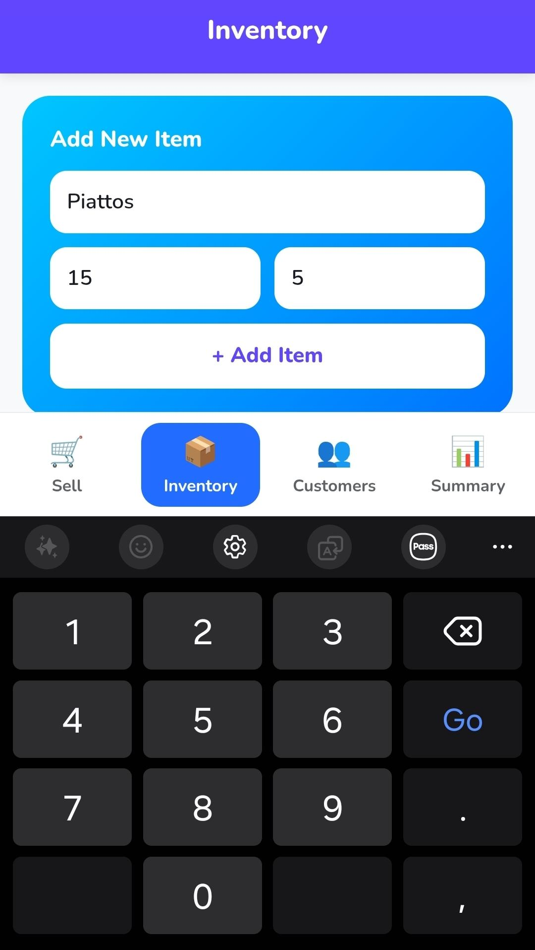
Figure 3. Add Inventory

To add items into the inventory system, go to the inventory tab and fill in the required parameters. Click “+Add Item” if you are done.
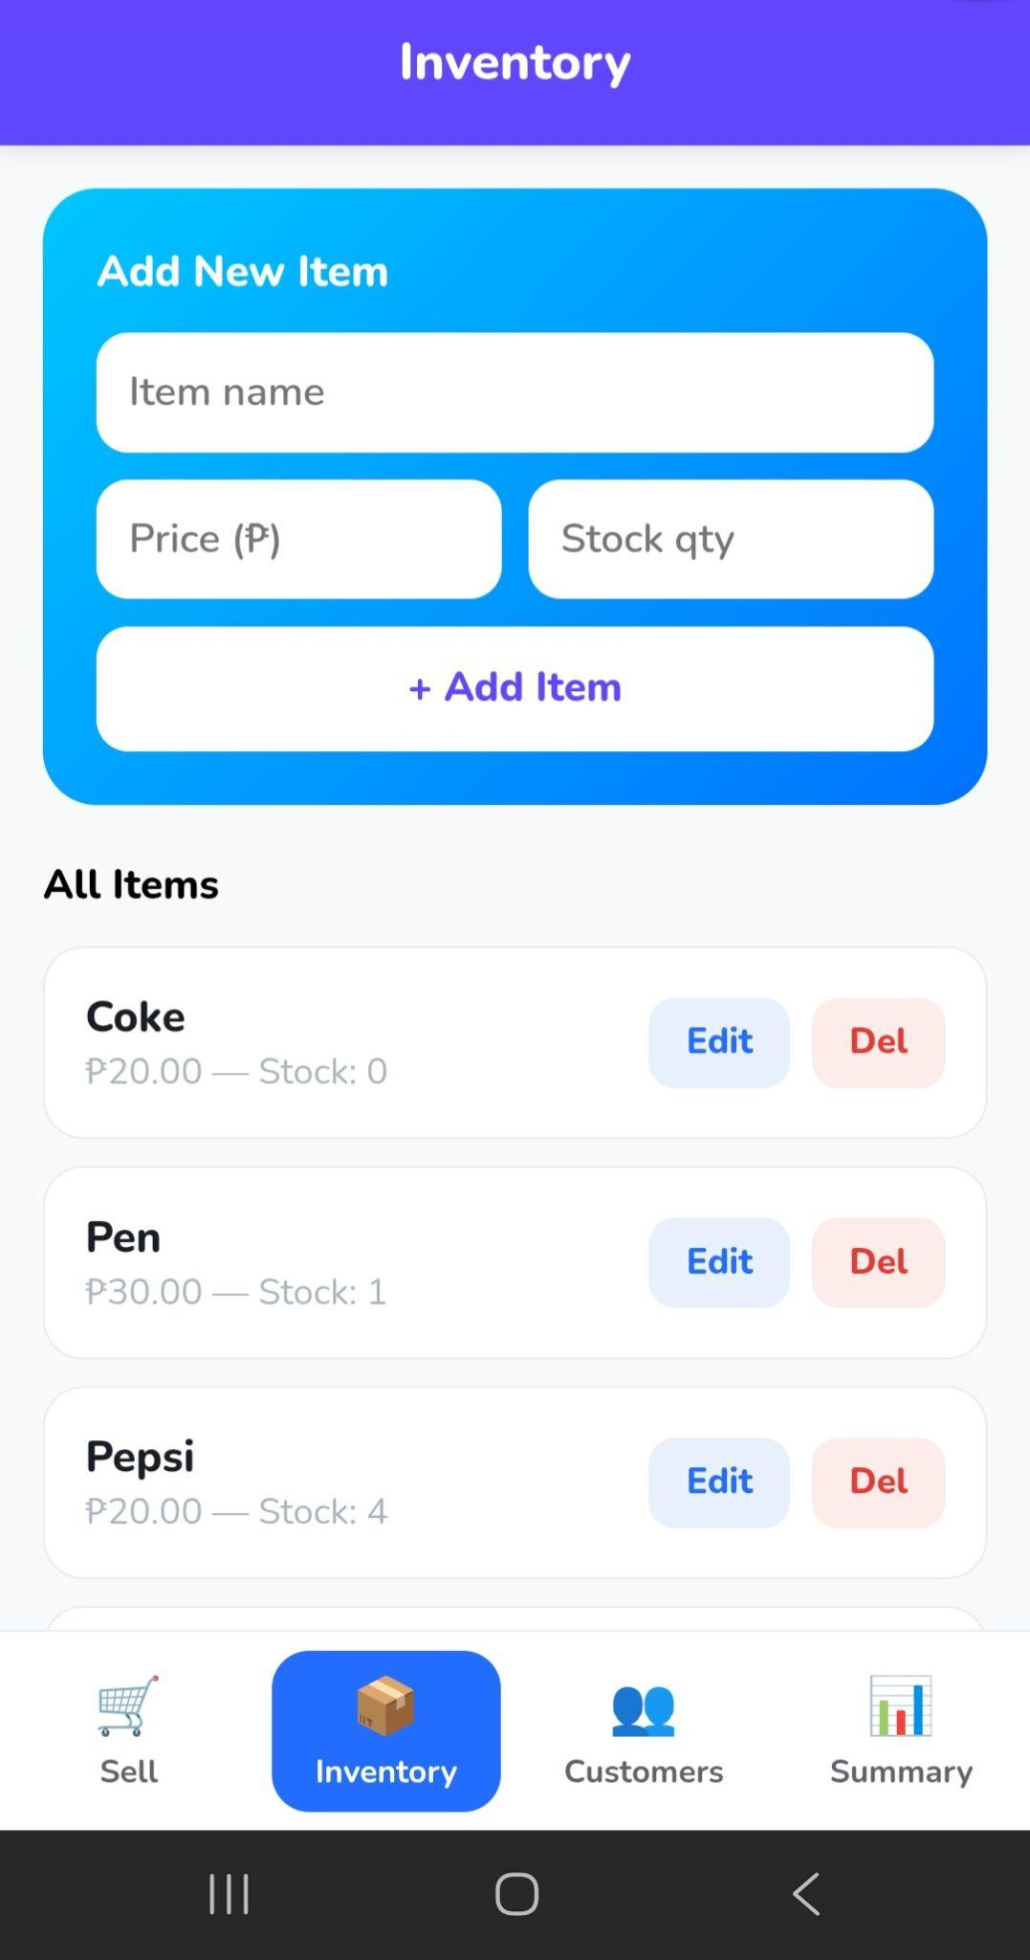
Figure 4. Inventory Items

You will see your inventory items listed in your inventory tab. To edit an item’s description or price or add new stocks, click "edit." Otherwise, if you want to delete an item, click "delete," and the system will prompt you to confirm item deletion.

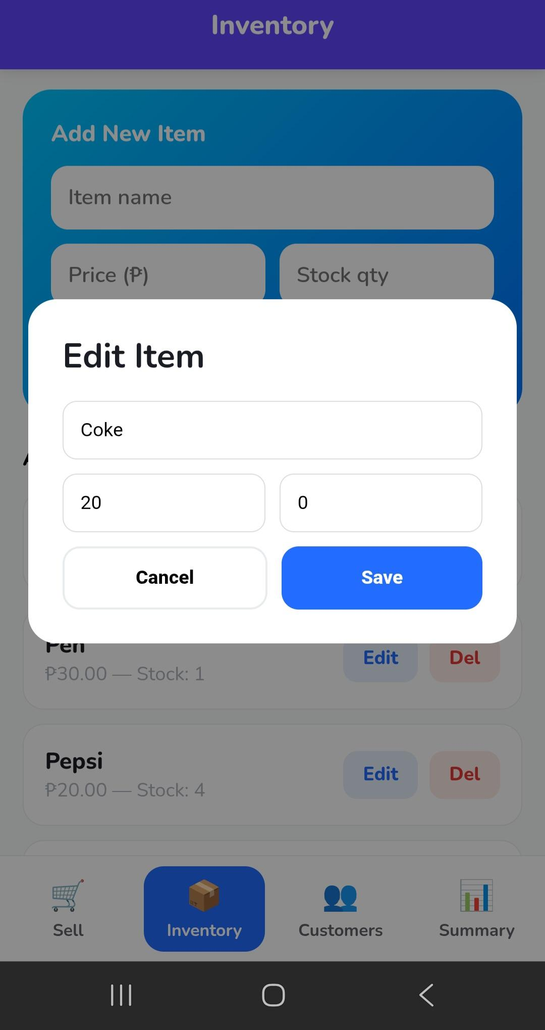
Figure 5. Edit Item
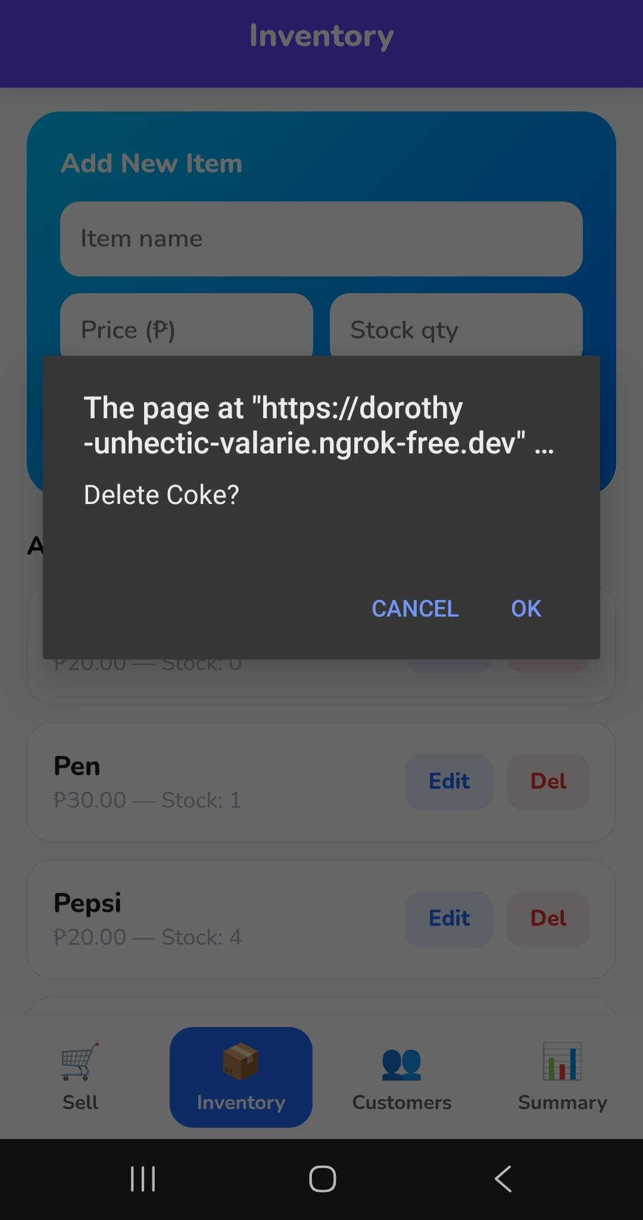
Figure 6. Delete Item

1.2 Record Sales and Debts (Sell Tab)

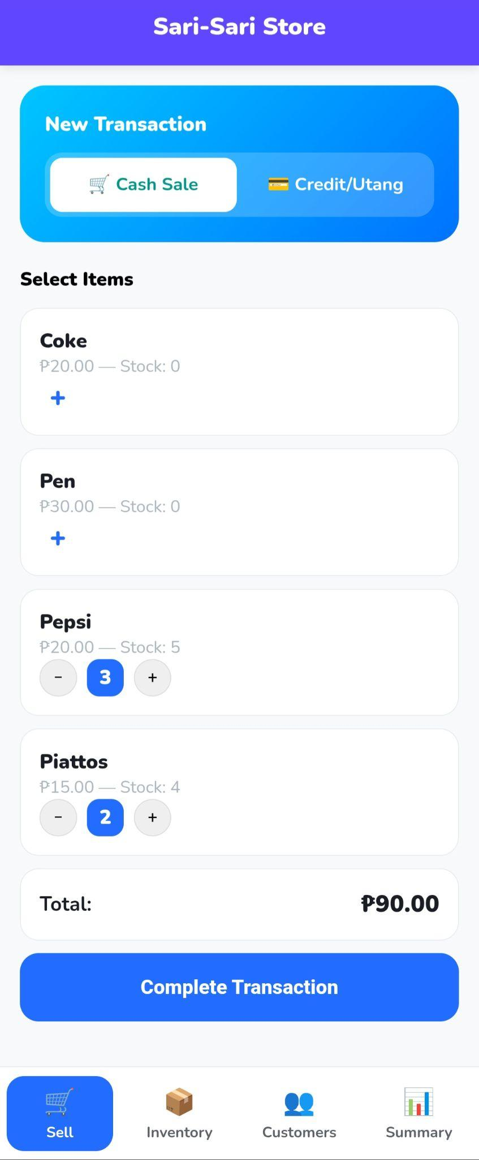
Figure 7. Record Sales

To initiate a transaction sale, go to the “sell” tab, set to “cash sale,” and select the items using the “+” icon. You can add more items as long as there are stocks available. A total bill will be displayed. To finalize, click “Complete Transaction.”

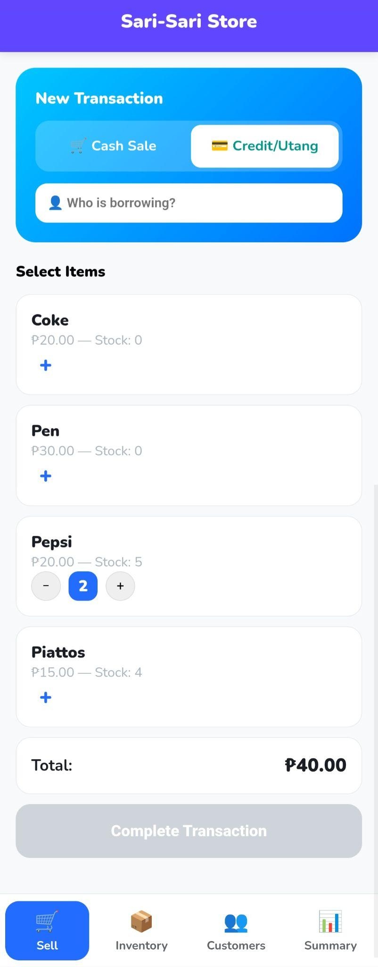
Figure 8. Record Debts

To record a debt, set the new transaction to “credit/utang,” indicate the name of the person borrowing, and add items that the person is borrowing. The total debt will be displayed. To finalize, click “Complete Transaction.”

1.3 Pay Debts (Customers Tab)

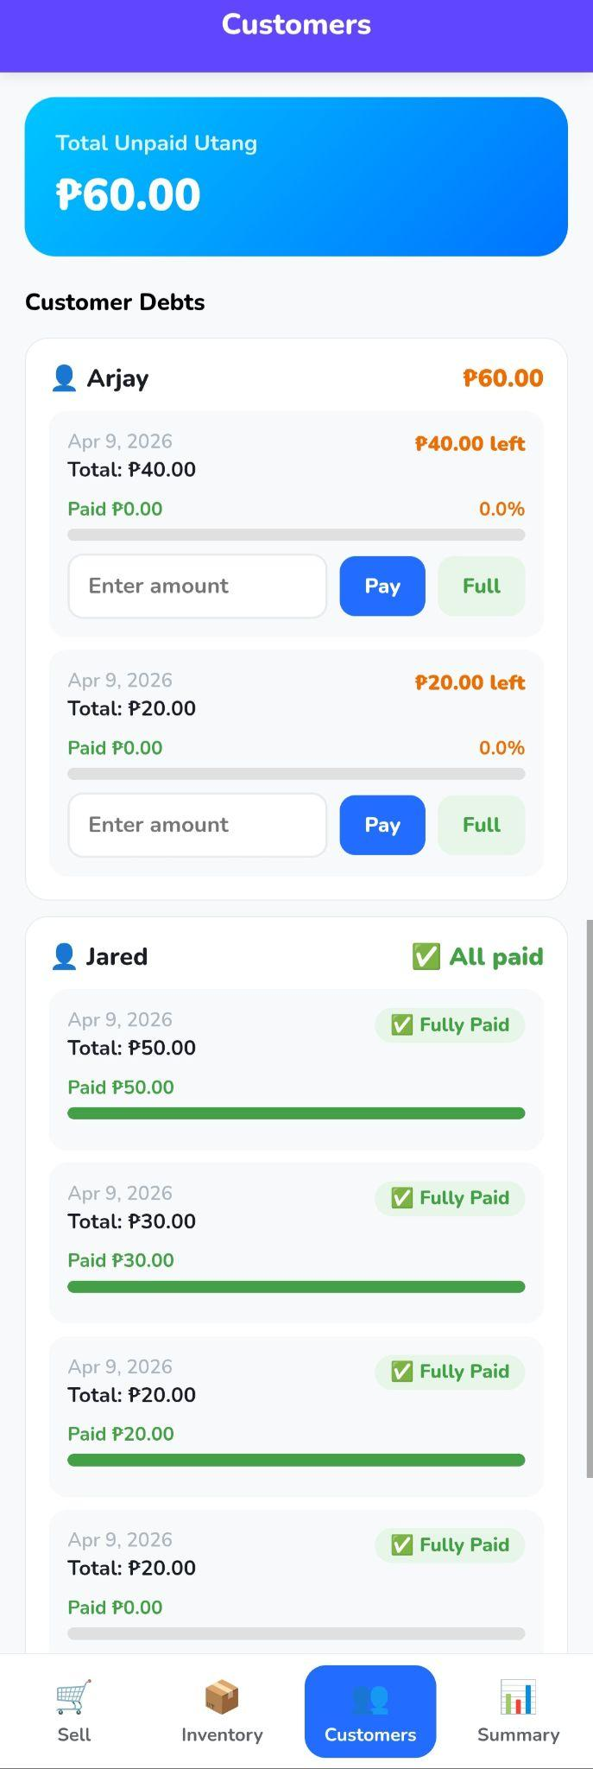
Figure 9. Pay Customer Debt

To settle a customer’s debt, he/she has the option to pay a partial or full payment. If a customer decides to pay partially, indicate the amount and press “Pay.” Otherwise, select full if the customer pays in full.

1.4 Summary

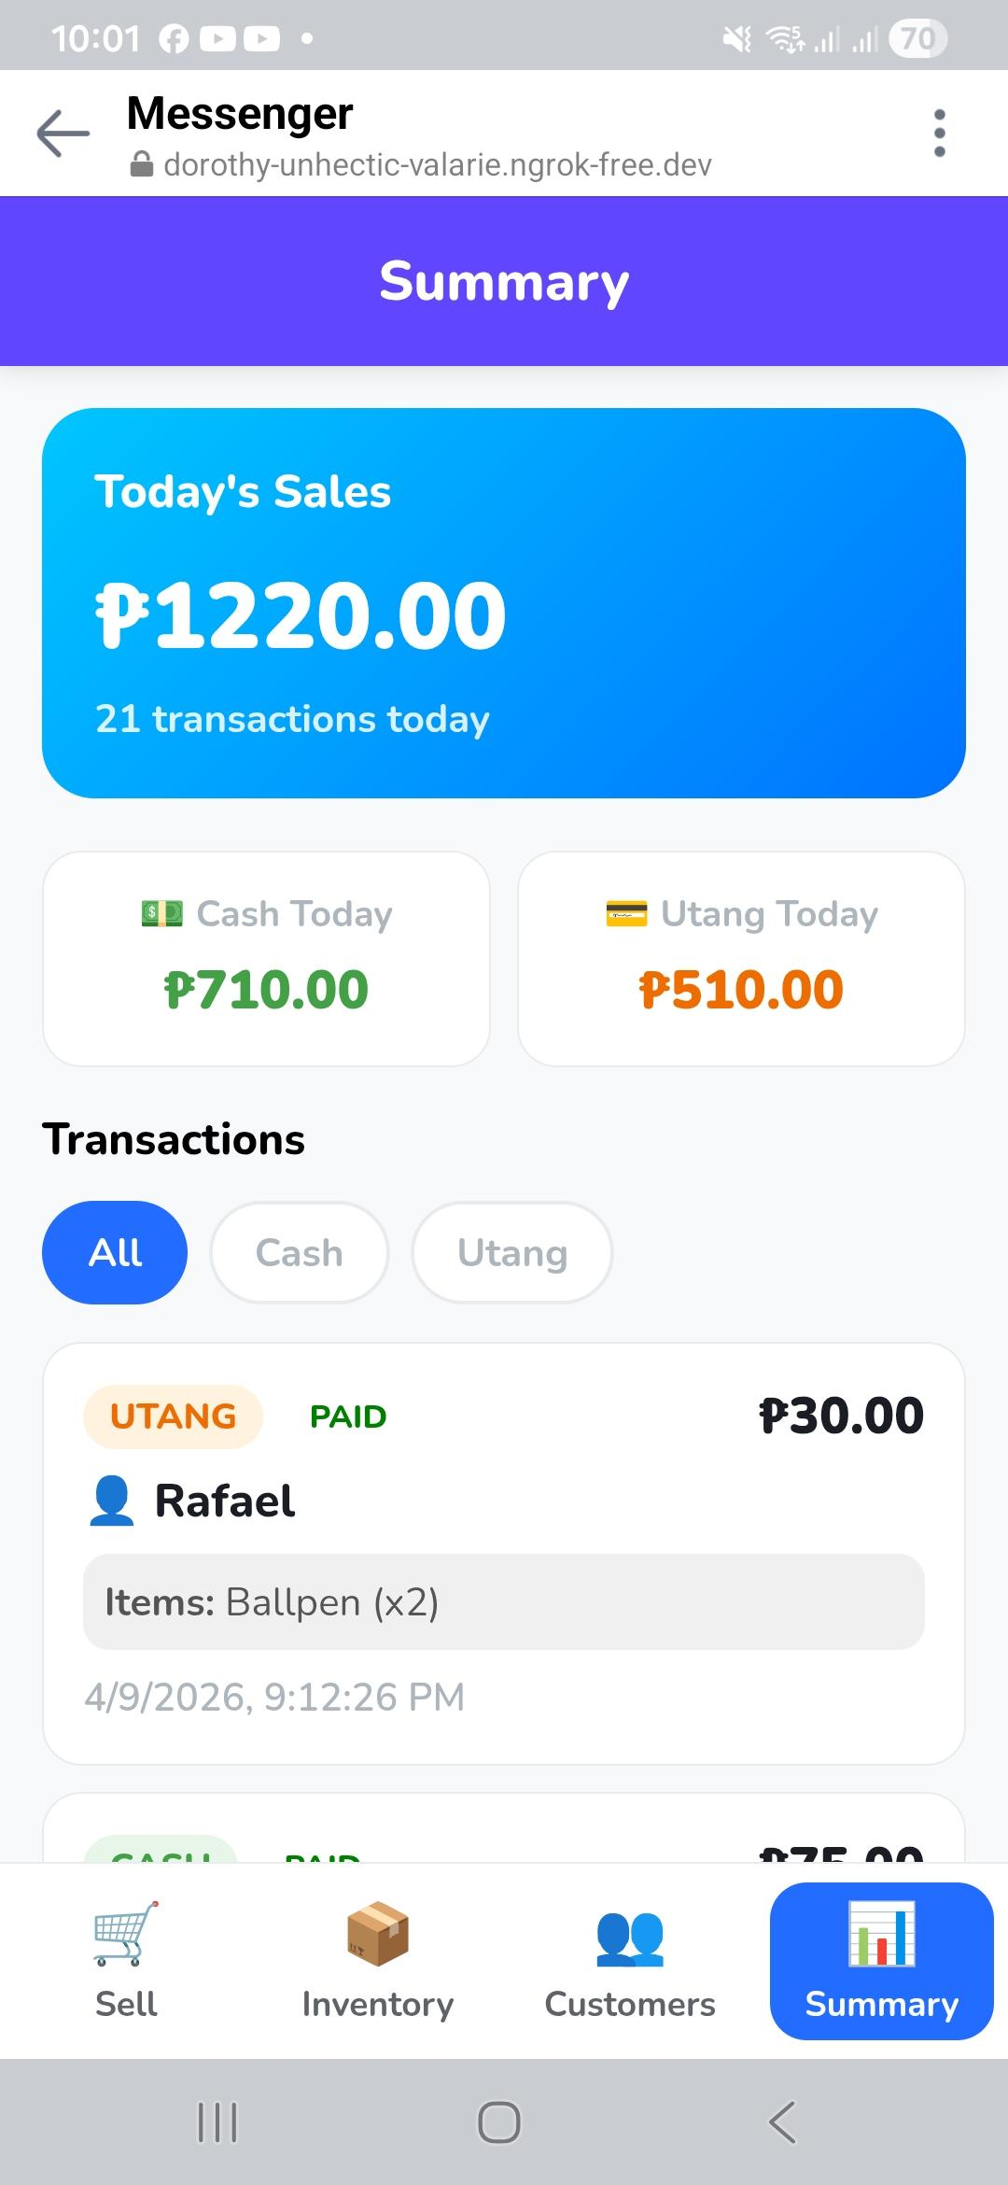
Figure 10. Summary Page

The summary page lists all recent transactions, total profits, and debts for that day. You may filter transaction types by cash or debts.

